[E134] High voltage PCB

Disconnect all the plugs from the high voltage panel and unscrew the indicated screws.

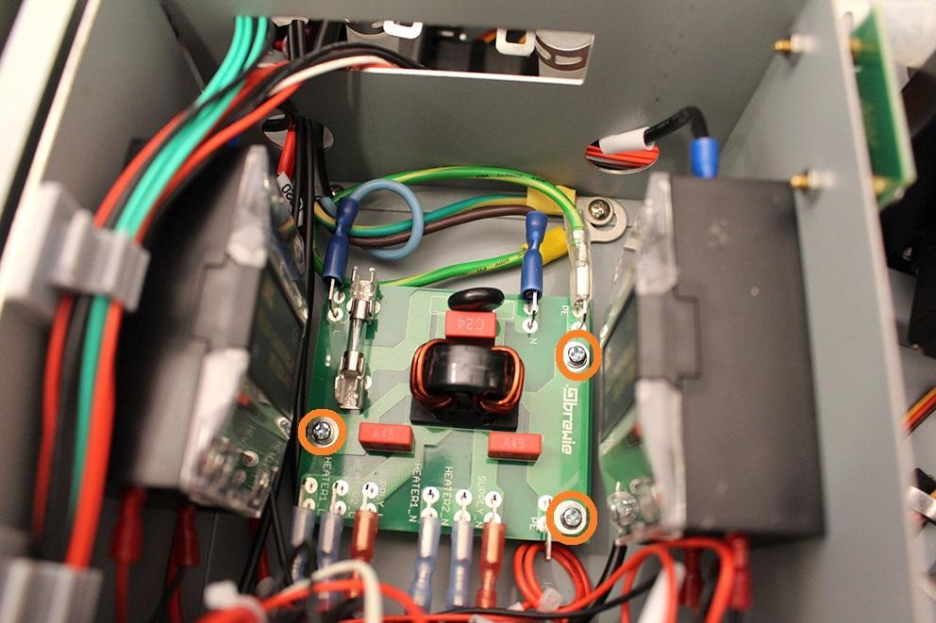

Now you can replace the part.

Reassemble consists of the same steps in reverse.